**Name: Nafinur Leo**

**Id: 20-42195-1**

**Course Name: Data Communication**

**Section: D**

**Lab Report Number: 02**

**Semester: 2021-2022 Fall**

**Submission Date: 10-10-2021**

**Lab Performance Task**

ID = AB-CDEFG-H

Here, my id is: 20-42195-1

A = 2, B = 0, C = 4, D = 2, E = 1, F = 9, G = 5, H = 1

Generate a composite signal using three simple signals:

x1 = a1*cos(2*pi*f1*t), x2 = a2*sin(2*pi*f2*t), x3 = a3*cos(2*pi*f3*t)

signal x = x1 + x2 + x3

a1 = A + C + 1 = 2 + 4 + 1 = 7

a2 = A + D + 2 = 2 + 2 + 2 = 6

a3 = A + E + 1 = 2 + 1 + 1 = 4

f1 = A + E + 1 = 2 + 1 + 1`= 4

f2 = A + D + 2 = 2 + 2 + 2 = 6

f3 = A + C + 1 = 2 + 4 + 1 = 7

a)Code:

close all;

clc;

fs = 8000;

a1 = 7;

a2 = 6;

a3 = 4;

f1 = 4;

f2 = 6;

f3 = 7;

t = 0:1/fs:2;

x1 = a1*cos(2*pi*f1*t);

x2 = a2*sin(2*pi*f2*t);

x3 = a3*cos(2*pi*f3*t);

nx = length(t);

signal_x = x1 + x2 + x3;

subplot(3,1,1);

plot(t, signal_x,'linewidth',2);

title('Time-Domain Representation of Signal');

xlabel('Time (s)');

ylabel('Amplitude');

fftSignal = fft(signal_x);

fftSignal = fftshift(fftSignal)/(nx/2);

f = linspace(-fs/2,fs/2,nx);

subplot(3,1,2);

plot(f, abs(fftSignal),'linewidth',2);

title('Frequency-Domain Representation of Signal');

xlabel('Frequency (Hz)');

ylabel('Amplitude');

xlim([-20 20])

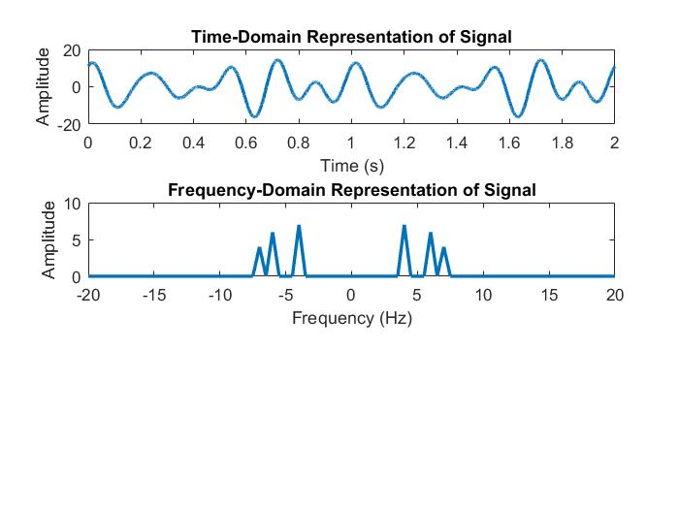

b)Code:

close all;

clc;

fs = 10000;

a1 = 7;

a2 = 6;

a3 = 4;

f1 = 4;

f2 = 6;

f3 = 7;

t = [-0.14:1/fs:0.14];

x1 = a1*cos(2*pi*f1*t);

x2 = a2*sin(2*pi*f2*t);

x3 = a3*cos(2*pi*f3*t);

nx = length(t);

signal_x = x1 + x2 + x3;

partition = -3.5:3.5;

codebook = -4:4;

[index,quants] = quantiz(signal_x,partition,codebook);

figure

plot(t,signal_x,'x',t,quants,'.');

legend('Original signal','Quantized signal');

